# Rentverse – Multi-Tenant Booking Platform

**Overview:** Rentverse is a scalable, full-stack rental application designed to support house, car, and book rentals with advanced KYC verification, real-time GPS tracking, and dynamic role-based booking flows. The system is built for high performance, modularity, and extensibility.

**Tech Stack:** Java, Spring Boot, PostgreSQL, Redis, Kafka, AWS (S3, EC2), Docker, REST APIs, JWT, React, Tailwind, WebSockets, Agora.io (mocked).

**Key Responsibilities & Architectural Contributions:**

* • Designed and implemented multi-role flows (Tenant, Owner, Admin) with strict access separation and concurrency-safe booking.
* • Developed core backend modules for real-time booking, conflict resolution, and post-booking flows (early checkout, extension, disputes).
* • Integrated KYC verification, image CAPTCHA, and AI-based metadata prefill logic using modular microservices.
* • Implemented GPS tracking using a hierarchical fallback system (car GPS → renter phone → manual toggle).
* • Created scalable chat and voice features with Agora integration (mocked locally, real code in comments).
* • Optimized booking overlap handling, availability matching, and shared rental flows with audit logging.
* • Devised admin-level override flows, tenant-tenant-owner group chat, and real-time alerts.
* • Engineered location-aware filtering (radius, sub-location, city-level) using latitude-longitude precision.
* • Supported referral gifting, dynamic premium pricing, and multilingual support using i18n libraries.

# Rentverse Architecture

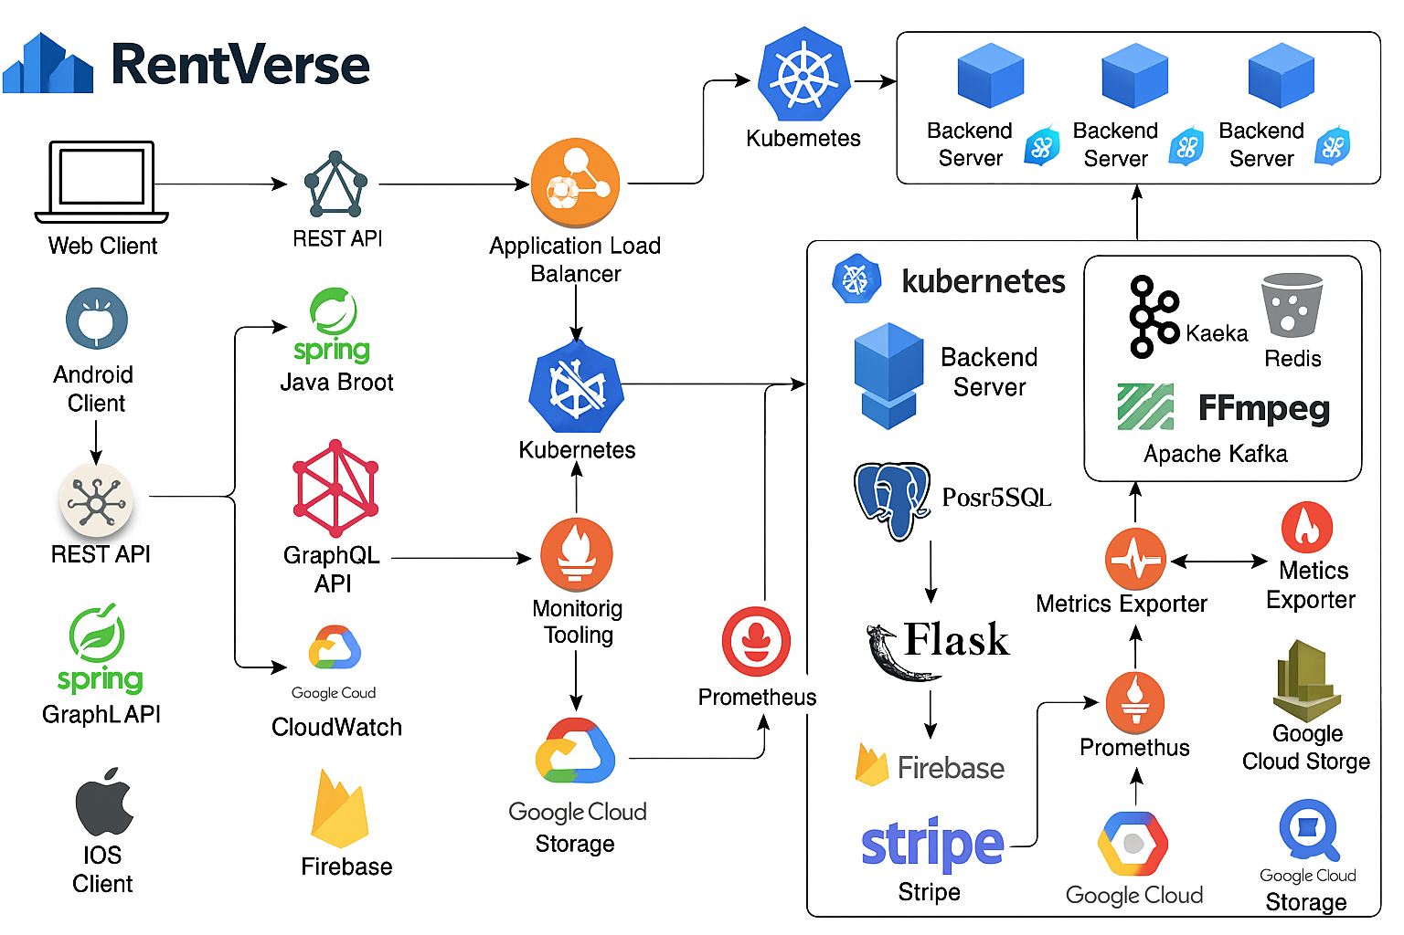

Rentverse System Architecture

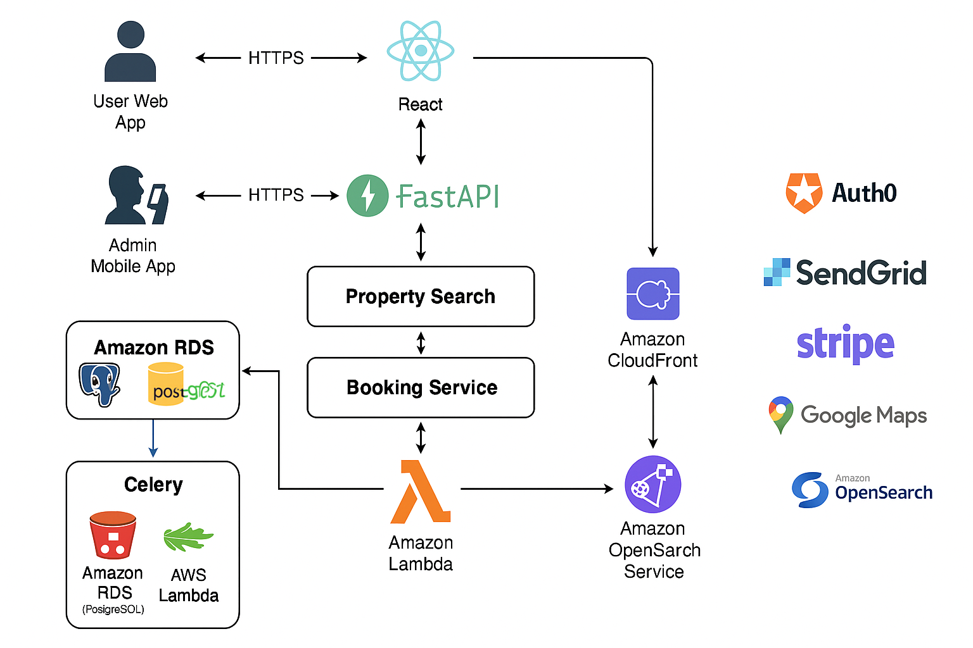

Rentverse Web Architecture

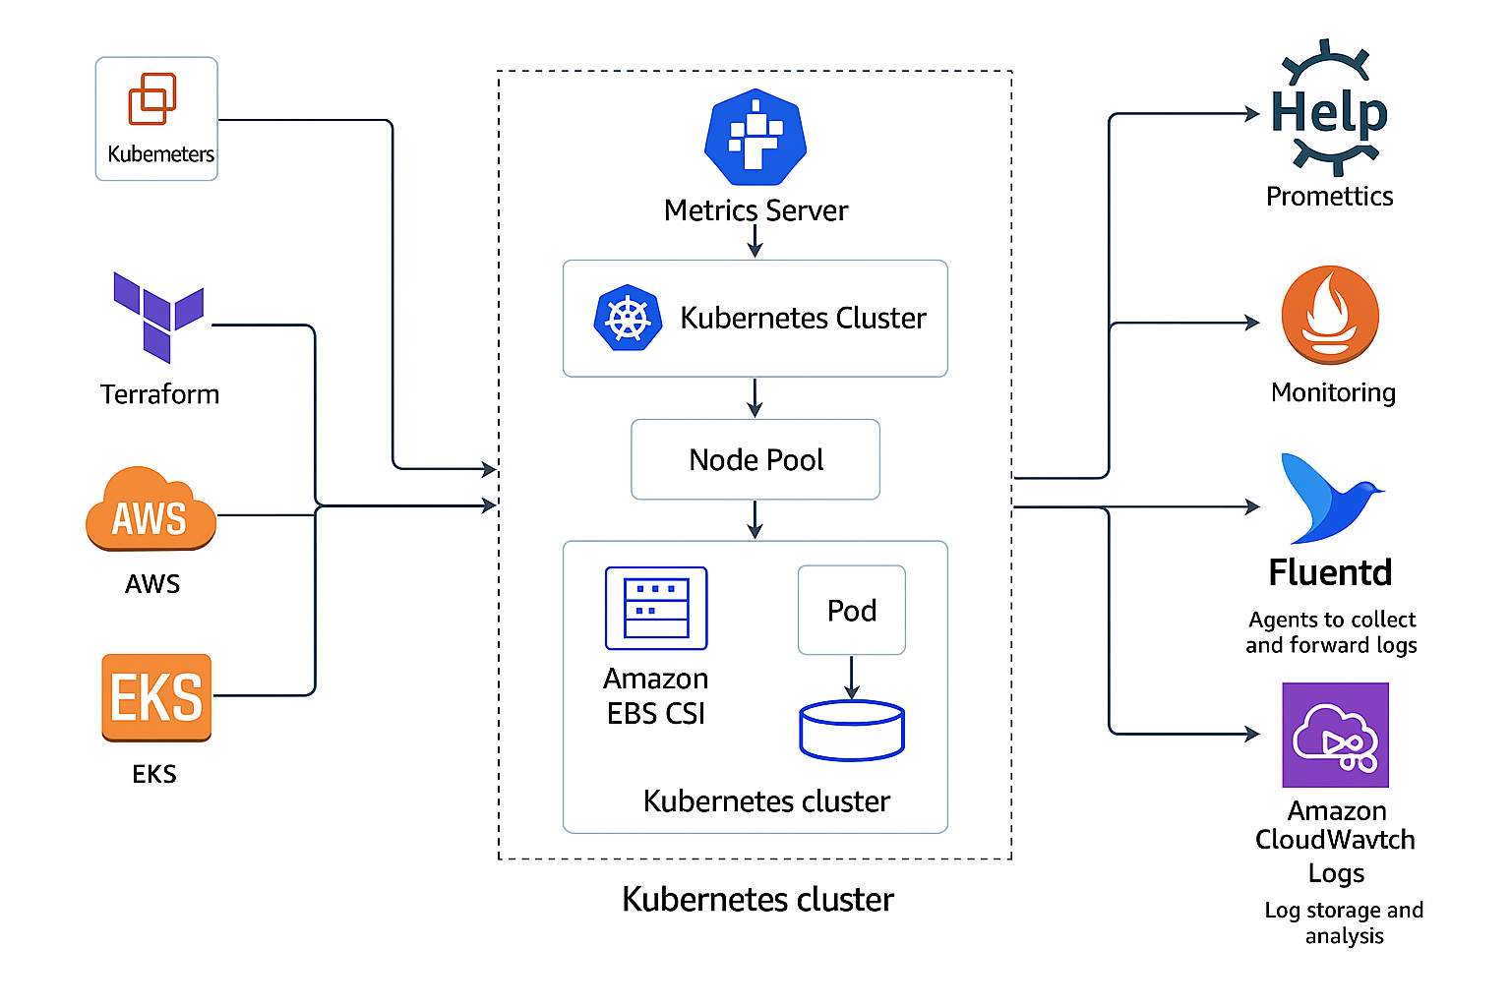

Kubernetes Cluster with Monitoring Architecture

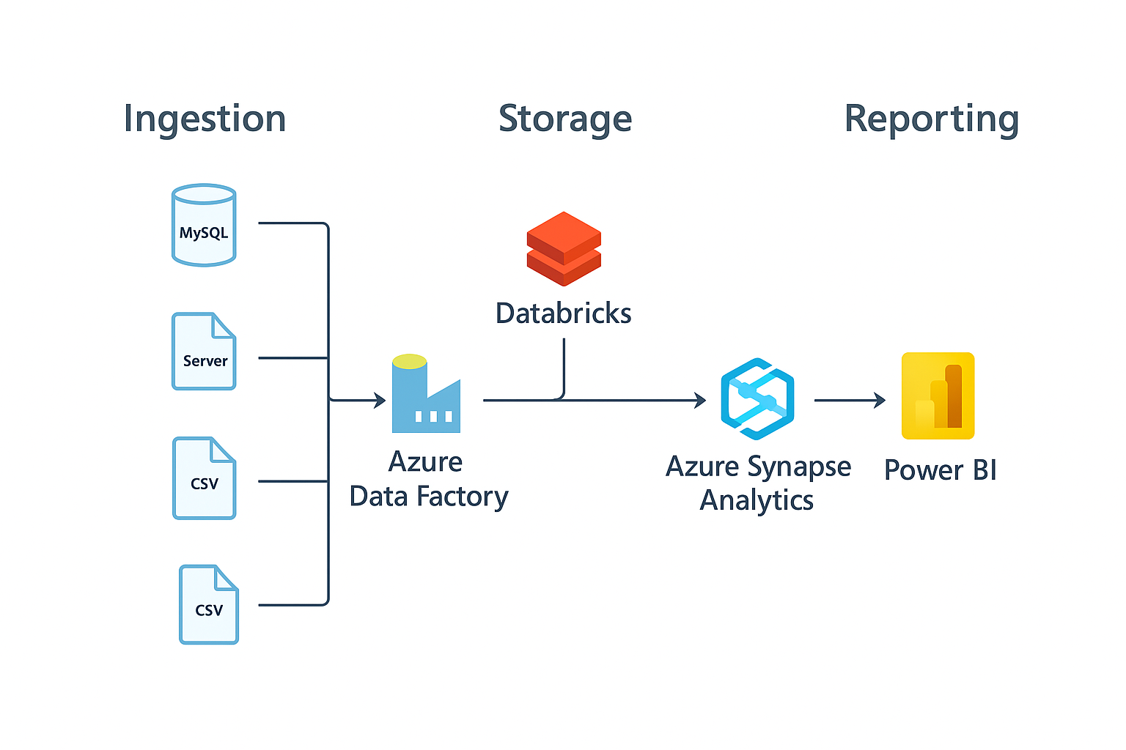

Data Flow Architecture_ Power BI System

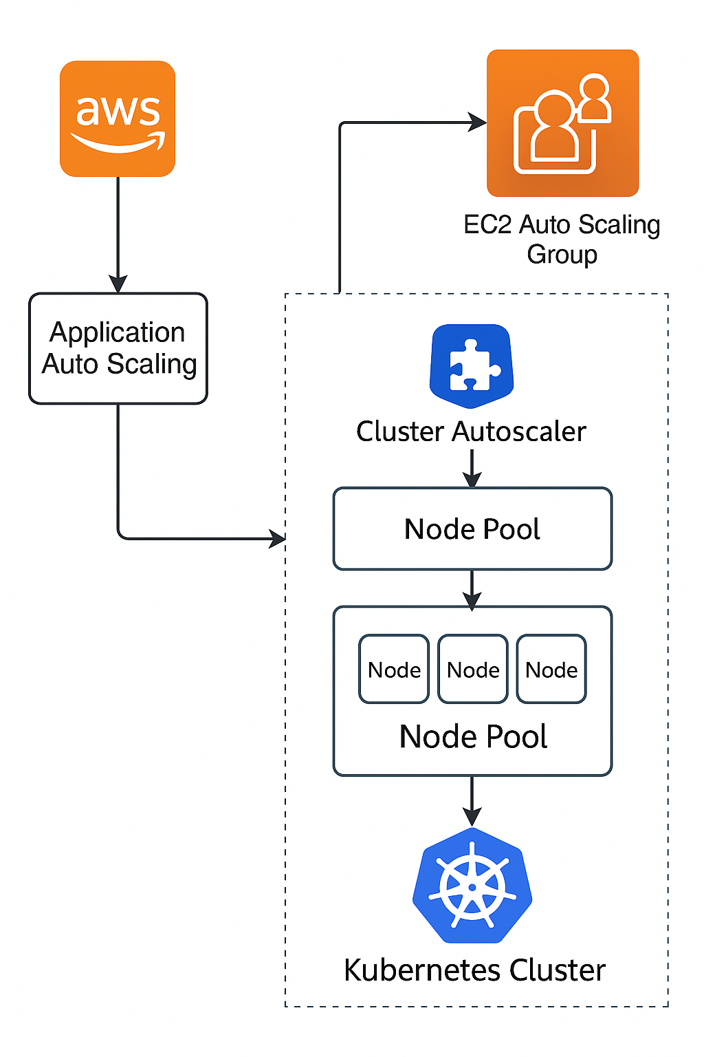

Kubernetes Autoscaling Flowchart with AWS

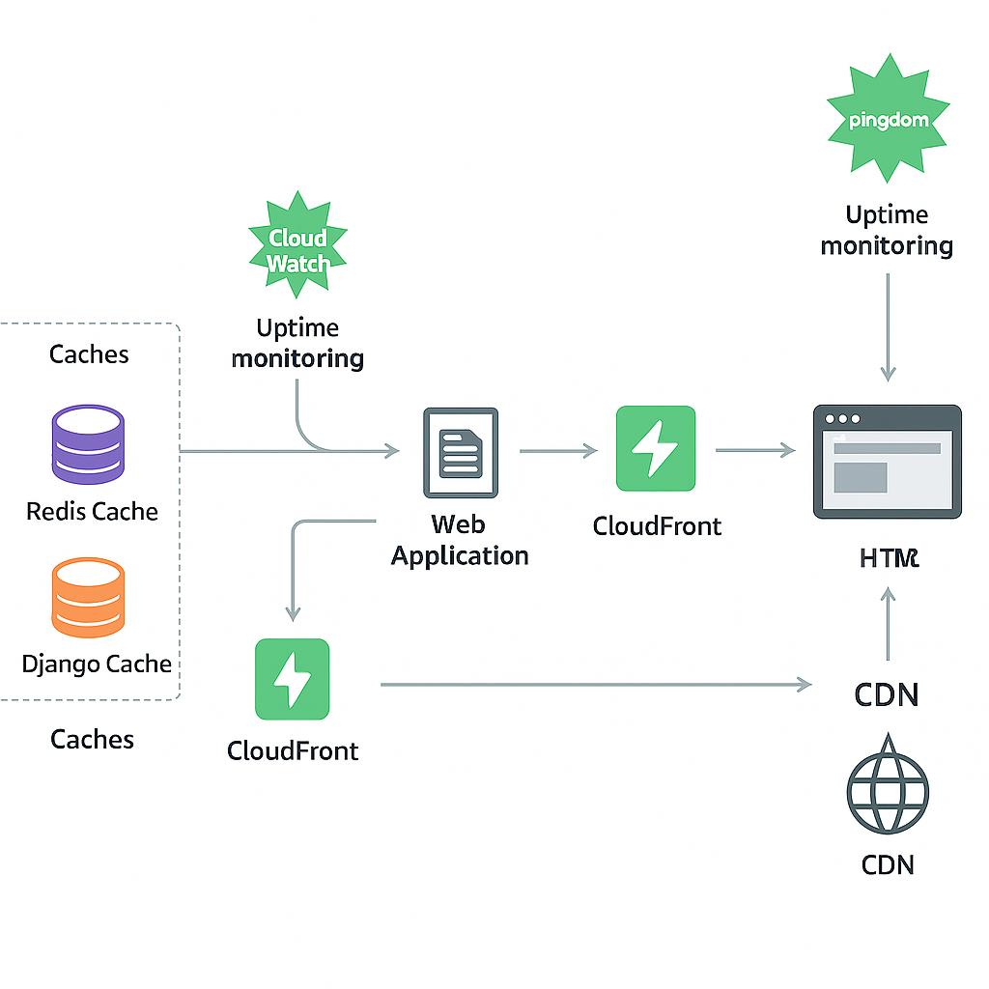

Rendering Pipeline Flowchart for Web App

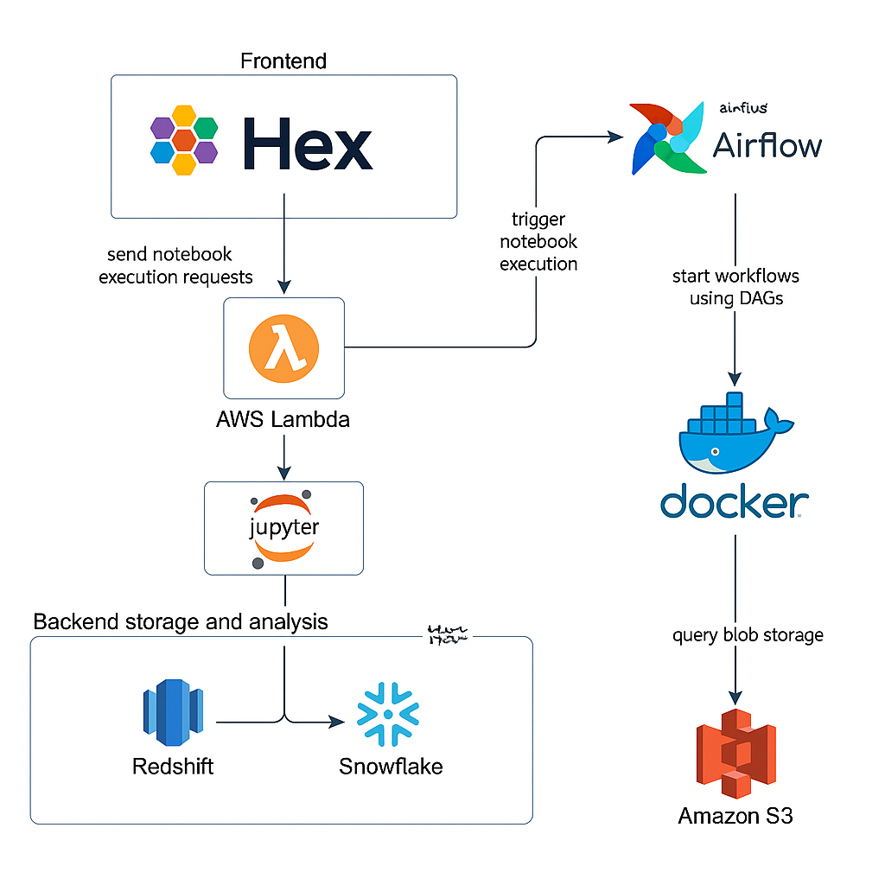

AWS Data Analysis Architecture Overview